Website: www.wallaroops.sa.edu.au Email: dl.0459.info@schools.sa.edu.au Phone: 88 232 190

Wallaroo Primary School Wellbeing Dog Risk Assessment
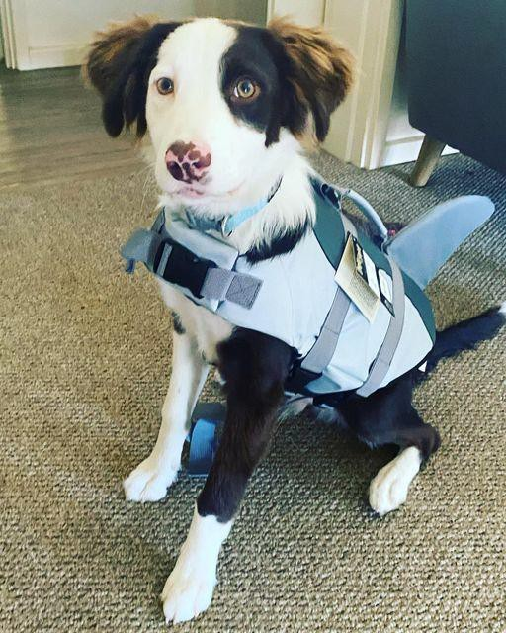

Hugo
Includes: Purpose and introduction
Interaction with pupils and staff
Pupils and staff interaction with the wellbeing dog Hygiene/Health
Activities involving the wellbeing dog, including walking Current Risk Assessments completed: March 24
Risk Assessments to be reviewed: March 25

Principal: Dominica Thomson Wellbeing/Intervention Leader: Jen Heinrich Business Manager: Nina Miles Extension Educator: Belinda Williamson Community Enrichment Coordinator: Jess Martin

Purpose
- Dogs teach children responsibility. Having to remember to feed, provide water and show support for a dog can give children a sense of importance and satisfaction that they can’t get from school or other chores. The relationship that develops can be life-changing for a child and a great support system as they themselves continue to grow and develop.
- Dogs teach children patience. Dogs do not always do as they are told first time!
- Dogs teach children compassion. Just like humans, dogs feel emotion and pain. They are prone to injuries and the infirmities of age during their relatively short lives.
- Dogs teach children about socialisation. Like most of us, dogs are social animals who enjoy and need attention and affection. By learning how to interact with a dog, children can learn how to better socialise with other children. If they can learn the social cues of a dog, then interacting with humans who can talk will be a walk in the park.
- Dogs are fun. Last, but certainly not least, dogs are a lot of fun. They greet you with a wagging tail every day and can cheer you up even on your worst day. Many people have studied dogs in attempts to decipher their behaviour, and the theories abound. However, you just have to witness the interactions between dogs and children to realise the potential for greatness. Dogs can sense when children with epilepsy are about to have a seizure, they can sense when a diabetic child’s sugar is low, and they can help children with severe physical disabilities find happiness in life. With the proper training and supervision, a dog can enrich a child’s life. After all, dogs are basically four- legged children who never grow up!

Introduction
The Wallaroo Primary Wellbeing dog ‘Hugo’ lives with our Principal, Dominica Thomson and her family. Hugo is a very caring and well-behaved dog who has the right temperament to become a real asset to Wallaroo Primary School. Hugo visits the vet for check-ups. Whilst he is there, they administer worm and flea treatments as well as make adjustments to his food intake to ensure he remains a healthy weight. In addition to the reasons for Hugo joining us outlined in the purpose we also believe he will improve the children’s abilities within the school and help to improve overall student well-being. While working as a ‘wellbeing dog’ at Wallaroo Primary School, Hugo is also undergoing training as a Therapy Dog, which Dominica Thomson is undertaking. This will allow Hugo to later work as a registered Therapy Dog within WPS and within our school community.

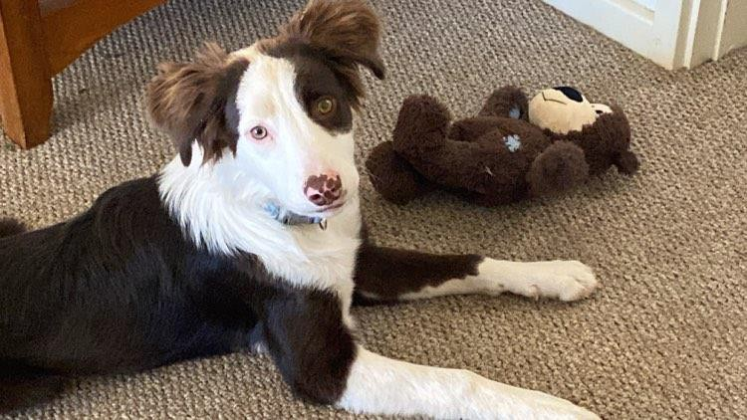

Area: Interaction with pupils and staff
Reason: to ensure the wellbeing dog interacts appropriately at all times.

Step 1 Identify the hazards | Step 2 Who might be harmed & how? | Step 3 What are you already doing? | Risk Rating Trivial /low  /medium/ high / stop | Step 4 Is anything further needed?
Wellbeing dog biting a child or adult | Child or adult could be hurt if the wellbeing dog bites | The wellbeing dog is trained not to bite. When the dog is approached in the correct way there is very limited danger.  Hugo lives with Dominica Thomson who handles him all the time to ensure that he is used to interaction with people/children. | Low | Ensure that children and adults do not interact with the wellbeing dog without supervision Ensure that all interaction with the wellbeing dog is completed in the agreed way. Visits also occur from a 2022, by a registered therapy dog Ryder and his handler so students and staff are used to Therapy dog visits and safety  procedures involved.
Jumping and scratching | If the wellbeing dog becomes excited there is a danger that he could jump up and knock a child over or leave a scratch mark | The temperament of Hugo and his training programme has involved not jumping up with praise/rewards being given when successful. The presence of Hugo at school was passed by the staff, Principal and Governing Council | Medium | Ensure that children and adults do not interact with the wellbeing dog without supervision. When outside the wellbeing dog will be on a lead under the control of an  authorised adult
Running loose | If the wellbeing dog was to run loose, he could hurt children/adults or damage property | The wellbeing dog will be contained at all times either in the office, or on a lead | Low | Monitor that the equipment used to contain the wellbeing dog is  appropriate and effective
Direct interaction with children/ staff | If the wellbeing dog is allowed to interact when not in the correct frame of mind children/ staff could be scratched | No interaction is allowed without authorisation.  Interaction will be cancelled if the wellbeing dog shows signs of incorrect behaviour.  Rewards/praise will be  given to reinforce the desired behaviour | Medium | Ensure that the dog is approached in the agreed manner  Hugo to undergo official Therapy Dog training.
Destruction of materials | If allowed the wellbeing dog may | The wellbeing dog with be contained at all times. | Low | Monitor that the equipment used to

 | chew/destruct some school materials/resources | The wellbeing dog will have his own toys to play with and normal school  resources will be removed |  | contain the wellbeing dog is appropriate and effective
Allergies | If a child is allergic to dogs they could become unwell | Children will not be in contact with the wellbeing dog if we have received notification from parents/guardians. If a child has an allergy the wellbeing dog will not carry out tasks near the  child | Medium | Students and staff are made aware of Hugo’s breed and monitored for allergic reactions. Parents to be notified as required.
Cleaning hands after interacting with the wellbeing dog | If hands are not cleaned children/adults  could become unwell | All adults and children will clean their hands after interaction with the wellbeing dog | Low | Remind children and adults to clean their hands

Area: Hygiene / Health
Reason: To ensure that pupils, staff and the wellbeing dog do not have an increased risk of illness as a result of the wellbeing dog being in school

Step 1 Identify the hazards | Step 2 Who might be harmed & how? | Step 3 What are you already doing? | Risk Rating Trivial /low  /medium/ high / stop | Step 4 Is anything further needed?
Worms / fleas | If the wellbeing dog is not treated for worms there is a danger that germs  can be transferred to humans | The wellbeing dog will be treated monthly at a local vet to ensure he is correctly treated for worms and fleas | Low | Monitor that vet visits happen promptly and take actions suggested by the vet
Faeces | If a child/adult come into contact with the wellbeing dog’s faeces some germs could be transferred | The wellbeing dog will only be walked under supervision. No child will be asked to pick up the dog’s faeces, this will always be undertaken by  the adult in supervision | Low | If a child finds faeces on the school field/playground they will report it to an adult
Allergies | If a child is allergic to dogs they could become unwell | Children will not be in contact with the wellbeing dog if we have received notification from parents/guardians. If a child has an allergy the wellbeing dog will not carry out tasks near the  child | Medium | Students and staff are made aware of Hugo’s breed and monitored for allergic reactions. Parents to be notified as required.
Cleaning hands after interacting with the wellbeing dog | If hands are not cleaned children/adults  could become unwell | All adults and children will clean their hands after interaction with the wellbeing dog | Low | Remind children and adults to clean their hands

Area: Activities involving the wellbeing dog, including walking
5
Reason: To ensure that the wellbeing dog has a meaningful and safe impact on the school community

Step 1 Identify the hazards | Step 2 Who might be harmed & how? | Step 3 What are you already doing? | Risk Rating Trivial /low  /medium/ high / stop | Step 4 Is anything further needed?
Visits to classroom | If the wellbeing dog visits a class and the children do not follow the correct procedure he may become over excited | The wellbeing dog will initially only make classroom visits with Dominica Thomson or other leadership staff. The children in classrooms will follow the agreed procedure or interaction will stop | Medium | Careful consideration will be given to when the wellbeing dog can visit classrooms and be under the control of the class teacher or  teaching assistant
School events | If the wellbeing dog is overwhelmed he may become aggressive or boisterous | The wellbeing dog will only attend school events if they are appropriate and he will be under the control of a supervising adult | Low | Monitor the wellbeing dog’s reaction to school events. If the school events are too overwhelming the wellbeing dog  might not attend school on that day
Other dogs (on and off the site) | If the wellbeing dog is overwhelmed he may become aggressive or boisterous | No other dogs will be allowed on the school premises. If another dog is seen this will be dealt with by the supervising adult | Low | Monitor the wellbeing dogs reaction when out walking.  Wellbeing dog, Hugo, will not attend school the same day Therapy  Dog Ryder visits.

Principal’s signature:

Governing Council Chair signature:
Review date: March 24
Dogs

Additional information/protocols:
Animals on site for day visits – no formal approval is required other than the Principal who is responsible for ensuring the welfare of the animal is taken care of.
https://edi.sa.edu.au/educating/programs-initiatives/animal-ethics/animal-day-visits Dogs are considered as category 1. Approval required for Category 1 animals is by Principal alone.
List of categories of animals but you will only need to look at category 1, which is for animals that are just to be observed under the instruction of their owner/handler.
https://edi.sa.edu.au/educating/programs-initiatives/animal-ethics/animal-care-activities
Daily Management of a Wellbeing Dog
The education support dog will:

- not be allowed on school premises if unwell
- be kept on a lead at all times and when moving between classrooms
- be under the supervision of a staff member at all times
- be up to date with all vaccinations, flea and worm treatments
- be well groomed and bathed regularly
- have a safe area in each space (classroom, yard etc)
- trained in obedience.
Students will:

- not have responsibility for the education support dog
- be reminded of the appropriate behaviours when around the dog (not to interfere with training regime)
- always be reminded to be kind, gentle, respectful and remain calm when around the dog
  - Not to stare into the dogs eyes
  - Not to put their face near the dogs face
  - Always approach the dog in a calm manner
- Not to disturb the dog when sleeping, eating or drinking
- Never to feed the dog
- Be reminded to wash/sanitise their hands before and after touching or patting the dog, especially before eating.
Health and Safety

- All persons should always wash/sanitise their hands before and after handling the dog.
- Any dog excrement will be cleaned up and disposed of by staff or the dog monitors.
- Students or staff with allergies to dog or animal dander will not be exposed to the wellbeing dog.
- Students or staff with aversions or phobias to animals will be respected and avoided.
Incident Protocols
Though trained to be gentle, any animal can snap, bite or jump up when confused or threatened. If a student is harmed or frightened by the Wellbeing dog then the following incident protocols will be followed:

- Seek immediate medical attention if required, follow first aid protocols.
- Parents of student/s involved to be notified immediately.
- Staff member (carer) to be notified immediately.

- The dog will immediately be removed from the school grounds pending an investigation.
- The carer of the dog will take the dog to the vet if required.
- Full investigation by the Principal or Delegate carried out.
- Online injury form to be completed and if serious, an IRMS to be completed.

